**Purpose of this Lab:**

* Basic idea of AND, OR and NOT gates and their ICs
* Working of logic Works and technique of mounting ICs on it

**Operation of AND gate according to its truth table**

Install IC (integrated circuit) for **AND (74LS08)** on the breadboard according to the connection diagram given below.

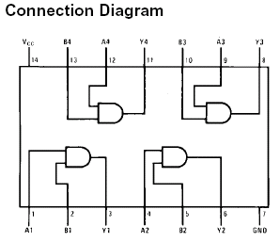

Fill the truth table according to the results.

**Operation of OR gate according to its truth table**

Install IC (integrated circuit) for **OR (74LS32)** on the breadboard according to the connection diagram given below.

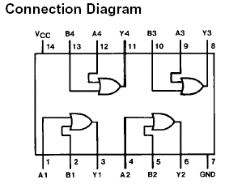

Fill the truth table according to the results.

**Operation of NOT gate according to its truth table**

Install IC (integrated circuit) for **NOT (74LS04)** on the breadboard according to the connection diagram given below.

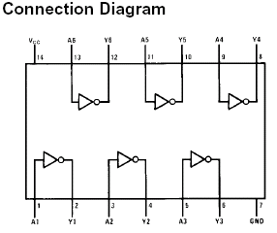

Fill the truth table according to the results.

**Operation of AND & OR gate with inverted inputs and fill its truth table for inputs and outputs.**